Nama : Anggun Nayla Galan Aubin

Absen : 07

Kelas : XR1

**TUGAS STUDI KASUS MENGGUNAKAN PRINSIP INHERITANCE,OVERRIDING & OVERLOADING**

**- Class Employe :**

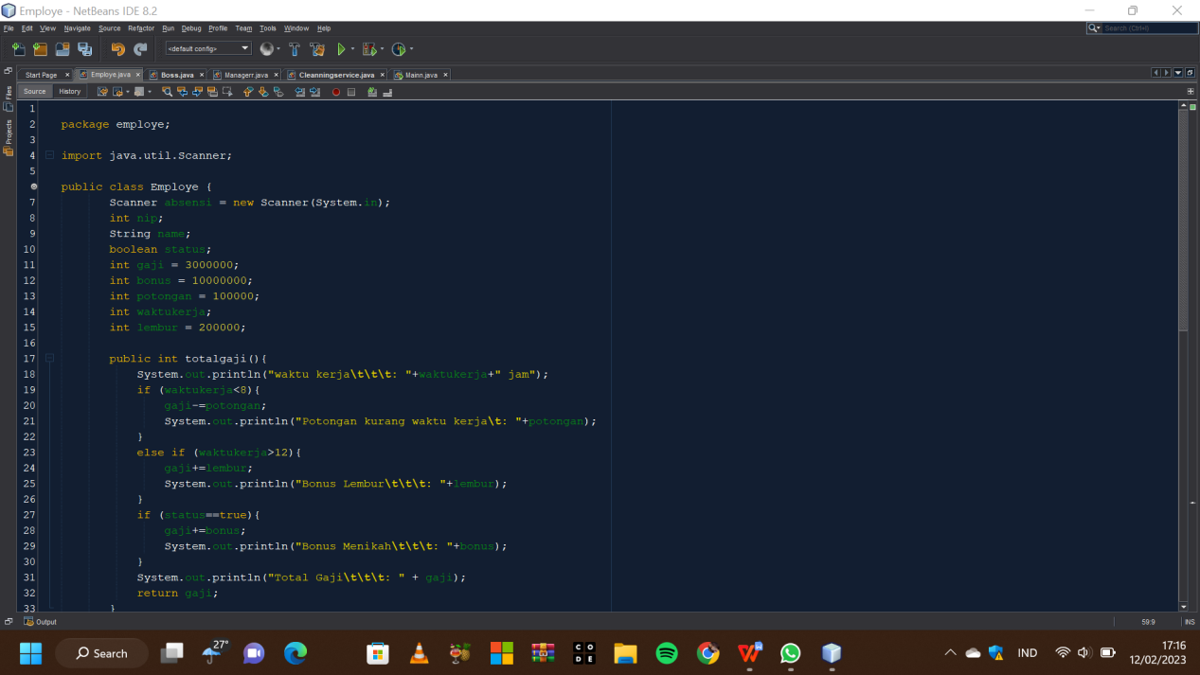

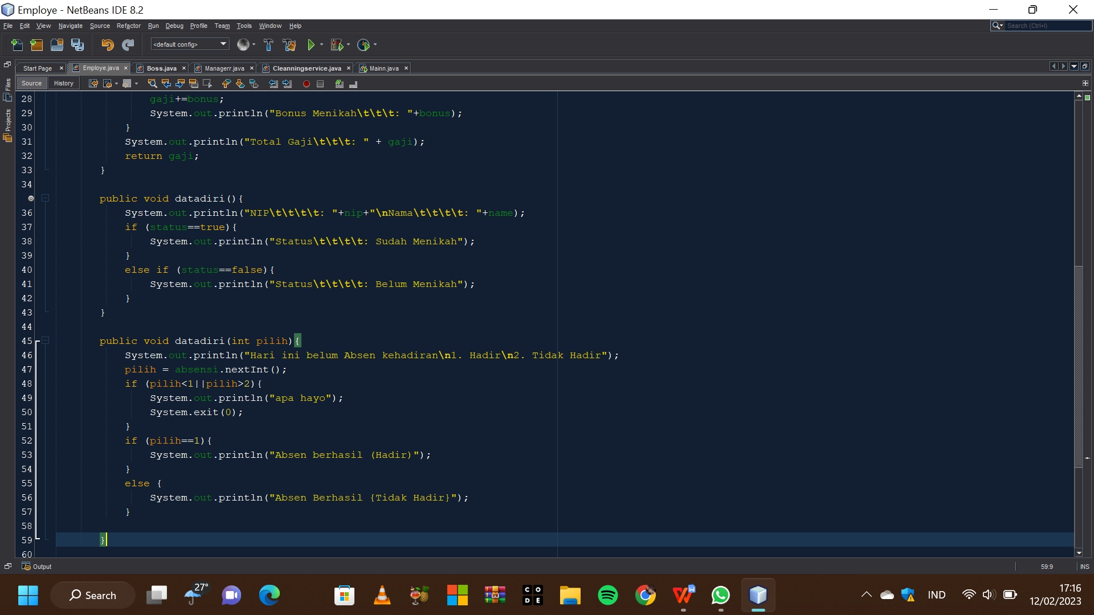

Penjelasannya :

- Membuat program tentang studi kasus gaji,bonus,potongan,waktu kerja(class employee,class boss, class manager,class cleanning service, dan mainn)menggunakan prinsip inheritance,overriding,overloading.

- Method void adalah method yang tidak mengembalikan nilai apapun setelah dieksekusi. Artinya, hanya melakukan sebuah proses.

- Implements digunakan untuk mewariskan interface.

**- Program :**

package employe;

import java.util.Scanner;

public class Employe {

Scanner absensi = new Scanner(System.in);

int nip;

String name;

boolean status;

int gaji = 3000000;

int bonus = 10000000;

int potongan = 100000;

int waktukerja;

int lembur = 200000;

public int totalgaji(){

System.out.println("waktu kerja\t\t\t: "+waktukerja+" jam");

if (waktukerja<8){

gaji-=potongan;

System.out.println("Potongan kurang waktu kerja\t: "+potongan);

}

else if (waktukerja>12){

gaji+=lembur;

System.out.println("Bonus Lembur\t\t\t: "+lembur);

}

if (status==true){

gaji+=bonus;

System.out.println("Bonus Menikah\t\t\t: "+bonus);

}

System.out.println("Total Gaji\t\t\t: " + gaji);

return gaji;

}

public void datadiri(){

System.out.println("NIP\t\t\t\t: "+nip+"\nNama\t\t\t\t: "+name);

if (status==true){

System.out.println("Status\t\t\t\t: Sudah Menikah");

}

else if (status==false){

System.out.println("Status\t\t\t\t: Belum Menikah");

}

}

public void datadiri(int pilih){

System.out.println("Hari ini belum Absen kehadiran\n1. Hadir\n2. Tidak Hadir");

pilih = absensi.nextInt();

if (pilih<1||pilih>2){

System.out.println("apa hayo");

System.exit(0);

}

if (pilih==1){

System.out.println("Absen berhasil (Hadir)");

}

else {

System.out.println("Absen Berhasil {Tidak Hadir}");

}

}

}

**- Class Boss :**

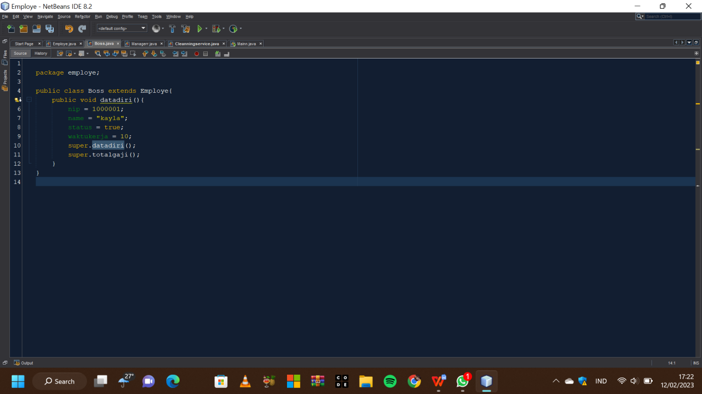

**- Program :**

package employe;

public class Boss extends Employe{

public void datadiri(){

nip = 1000001;

name = "kayla";

status = true;

waktukerja = 10;

super.datadiri();

super.totalgaji();

}

}

**- Class Manager :**

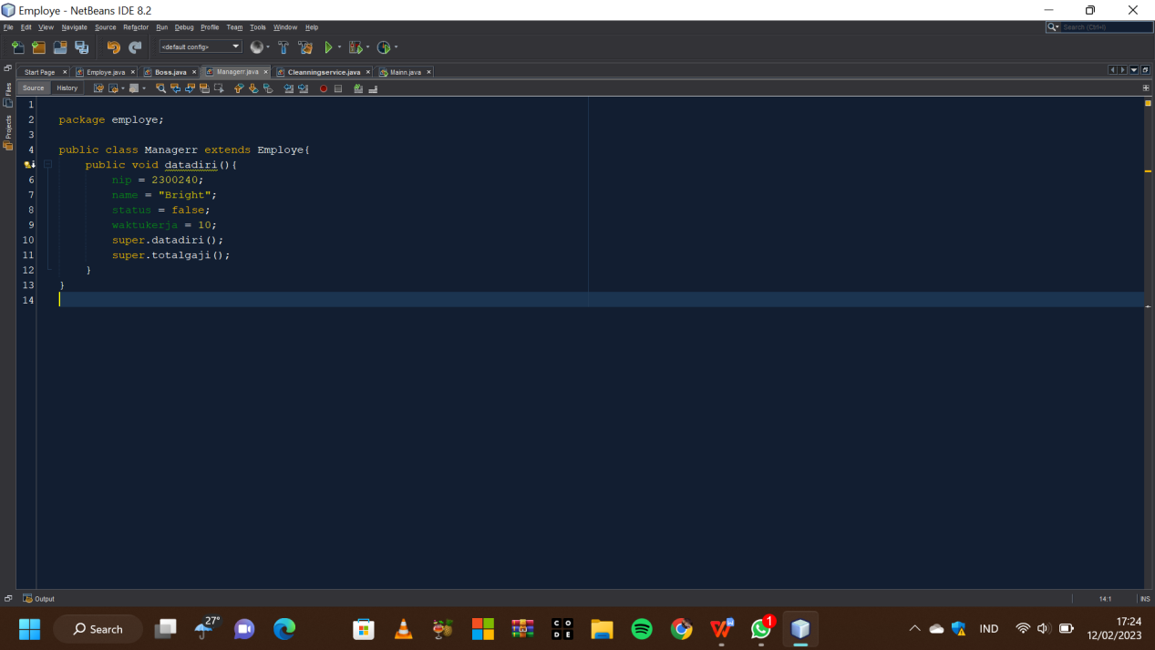

**- Program :**

package employe;

public class Managerr extends Employe{

public void datadiri(){

nip = 2300240;

name = "Bright";

status = false;

waktukerja = 10;

super.datadiri();

super.totalgaji();

}

}

**- Class CleaningService :**

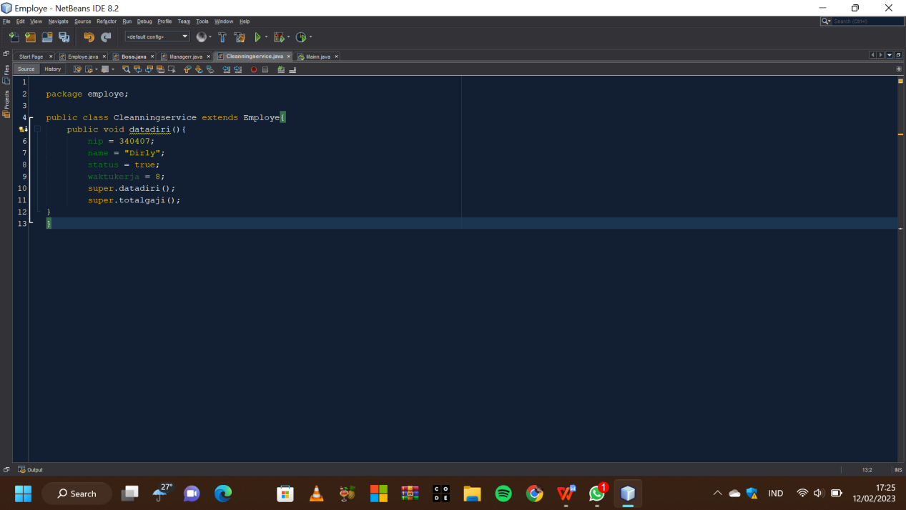

**- Program :**

package employe;

public class Cleanningservice extends Employe{

public void datadiri(){

nip = 340407;

name = "Dirly";

status = true;

waktukerja = 8;

super.datadiri();

super.totalgaji();

}

}

**- Mainn :**

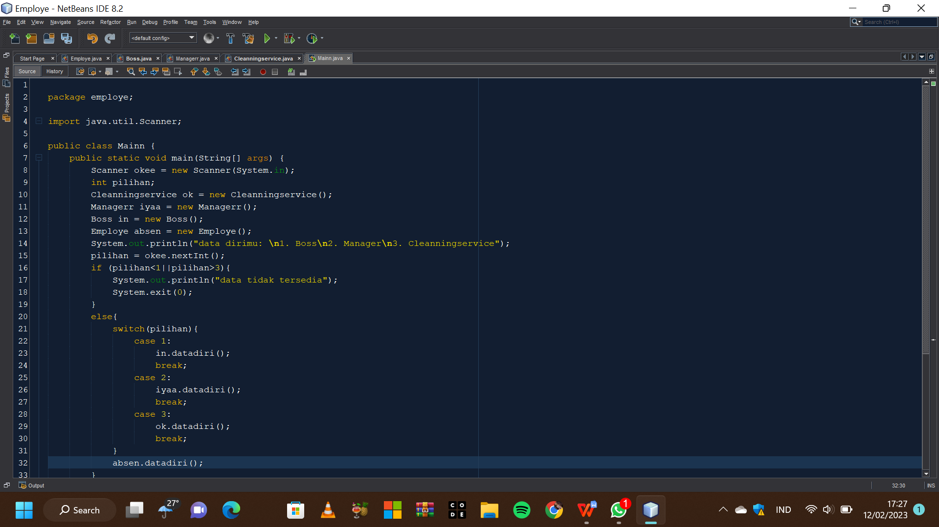

**- Program :**

package employe;

import java.util.Scanner;

public class Mainn {

public static void main(String[] args) {

Scanner okee = new Scanner(System.in);

int pilihan;

Cleanningservice ok = new Cleanningservice();

Managerr iyaa = new Managerr();

Boss in = new Boss();

Employe absen = new Employe();

System.out.println("data dirimu: \n1. Boss\n2. Manager\n3. Cleanningservice");

pilihan = okee.nextInt();

if (pilihan<1||pilihan>3){

System.out.println("data tidak tersedia");

System.exit(0);

}

else{

switch(pilihan){

case 1:

in.datadiri();

break;

case 2:

iyaa.datadiri();

break;

case 3:

ok.datadiri();

break;

}

absen.datadiri();

}

}

}

**- Output :**

